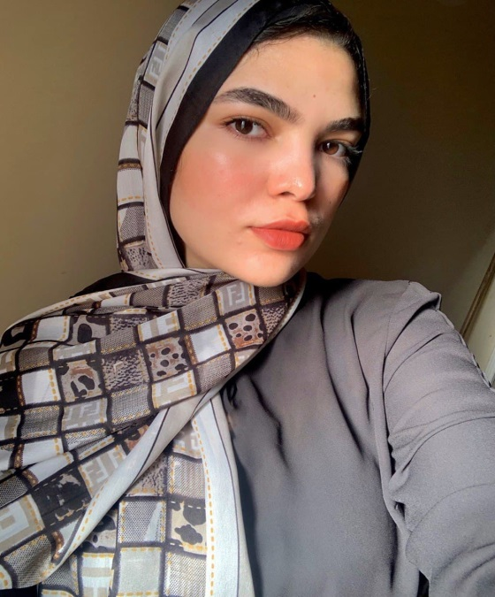

***An educational guide for nanopore sequencing in the classroom***

**Assignment 1 : Abstract And Introduction Summary**

***Abstract : -***

**1-The last decade has witnessed a remarkable increase in our ability to measure genetic information. Advancements of sequencing technologies are challenging the existing methods of data storage and analysis.**

**2-Future generations of biologists must be more computationally aware and capable. This means they should be trained to give them the computational skills to keep pace with technological developments.**

***Introduction : -***

**1-what defines a biologist? In short, a biologist is a person who studies life and living organisms.**

**2-Biology covers diverse topics such as molecular biology, structural biology, ecology, evolution, genetics, microbiology, immunology, and biotechnology. Importantly, most (if not all) of these topics have undergone incredible progress due to rapid discoveries and technological advances [1,2]. As such, a modern biologist has the inevitable tasks of adapting to rapid change and mastering new knowledge and technology.**

**3-One of the most important revolutions in the field of biology was caused by the development of next-generation sequencing (NGS) technologies. Using massively parallel processing of samples, NGS dramatically reduces sequencing time and costs, enabling the sequencing of entire genomes.**

**4-Currently, genome sequencing and analysis have become a crucial component in biology, as evidenced by recent scientific breakthroughs [3,4] and by the exponential increase of reported genomes on GenBank (e.g., from 30,000 sequenced prokaryotic genomes in 2014 [5] to 183,000 in 2018.**

**5-not only do biologists need to adapt and learn how to use these emerging technologies, they also need to learn how to mine the ever-growing mountain of genomic information they generate, which requires bioinformatics skills. Now, the question is how do we train this generation of biologists so that they have the required computational skills?**

***Name : Omnya Abd El Fattah Ali***

***3rd year Bioinformatics Department***